WEEK NUMBER: |  | 3
STUDENT NAME: |  | Anas Al Azad
STUDENT ID: |  | 105694136
WEEK # | 3
Dates covered: | 17–23 August 2026
Lab tasks | What I did |  | TIME SPENT | Learning & Problems
Concept + set-up  Make sheet 'Concept', accounts | - Read both sheets. Made a free Pinecone account and an index (Lab3_class: dense, 1024 dimensions, cosine). Reused my Gemini key from Week 1.  - Concept demo (concept_demo.py): asked Gemini a question about our notes once with no context and once with the right chunk pasted in |  | 1 h | Learning:  - Keyword search only finds the exact words; semantic search compares meanings, so 'how do agents get better over time?' can still find the learning-agents part.  - A vector DB's whole job is to find the right chunk and paste it into the prompt for me, so I don't have to do it by hand.  Problems:  - None really for this one.
Make – Part 1: ingestion  RAG Ingestion blueprint | - Created a new scenario and imported RAG Ingestion.blueprint.json: Google Drive → Chunk text (200 / 20) → Iterator → Gemini embeddings (1024) → Pinecone upsert.  - Uploaded intelligent_agents_overview.txt to my Google Drive and connected my own Google Drive, Gemini and Pinecone accounts.  - Ran it once: Make stored 8 records in namespace week3-lab. Opened one in Pinecone to check the text and source metadata were saved. |  | 1 h | Learning:  - The Iterator makes the next modules run once per chunk – that's why the Gemini and Pinecone modules show one operation per chunk.  - Record ID = file name + chunk position, so running it again overwrites the same records instead of adding copies.  Problems:  - The blueprint still points to the tutor's connections and the tutor's Drive file, so every module had to be re-connected to my accounts and the file picked again before it would run.  - Make made 5 chunks with chunk size 200 / overlap 20 – my Python chunker makes 9 (it counts words; the sheet says Make's unit isn't given).
Make – Part 2: query  RAG Query blueprint | - Imported RAG Query.blueprint.json: Set variable → Gemini embeddings → Pinecone search (Limit 3) → Text aggregator → Gemini response → Get variable.  - Set the question to 'What is a learning agent?', clicked *Run once* and read the answer at the last module. Then tried 'What's the weather in Melbourne?'.  - For 'What is a learning agent?' the search (Limit 3) returned chunks 0, 5 and 4.  - Modification: Limit 3 → 1 and → 5, ran again and compared (details in the deliverable below). |  | 1 h | Learning:  - The text aggregator glues the 3 chunks together with '---' between them so Gemini sees them as separate pieces of context.  - The system prompt is what makes it say 'not enough information' instead of guessing.  Problems:  - Same as Part 1: the Gemini (×2) and Pinecone modules had to be switched to my own connections.  - The blueprint's Set variable still had the question 'What's the current weather' – changed it to my own question first.
Python – set-up + ingestion  simple-rag/ingest.py | - Made the project like section 4 of the sheet (data/, ingest.py, query.py, .env, .gitignore, requirements.txt) and installed google-genai pinecone python-dotenv. Keys are only in .env, which git ignores.  - python ingest.py: 10,425 characters → 9 chunks (eight of 200 words + one of 90) → 1024 numbers each → 9 records in namespace week3-code-lab.  - Checked a record in the Pinecone console: the vector is there and the metadata has text, source and chunk_number. |  | 1 h | Learning:  - Overlap = the last 20 words of a chunk are repeated at the start of the next one, so a sentence cut at a boundary isn't lost.  - 1024 has to be the same in three places: ingest, query and the index.  Problems:  - Pinecone can take a few seconds before new records show up (the sheet's troubleshooting mentions it), so ingest.py waits until the count is right before it says it's done.
Python – query  simple-rag/query.py | - python query.py – "What is a learning agent?": printed the top 3 chunks with their scores, then Gemini's answer (partial – only 2 of the 4 parts: performance element and critic). The top 3 were chunk 0 (0.7870), chunk 5 (0.7858) and chunk 4 (0.7515).  - Out-of-scope "What's the weather in Melbourne?": it said "I don't have enough information in the provided documents." and didn't make anything up. Pinecone still returned 3 chunks (0, 2 and 3), but the scores were low (0.5163, 0.5138 and 0.4913) |  | 0.5 h | Learning:  - Printing the retrieved chunks first (the 'R' in RAG) shows whether a bad answer is the search's fault or Gemini's.  - A low top score is a good sign that the documents just don't cover the question.  Problems:  - None really for this one.
Experiment A – top-k  experiments.py | - Same question ('What is a learning agent?'), top-k 1 / 3 / 5: top-k 1 only got chunk 0 (general agent definition) and Gemini said it didn't have enough information (9-word answer); top-k 3 got chunks 0, 5 and 4 and gave a partial answer (2 of the 4 parts); top-k 5 got the same 3 plus 2 more (incl. chunk 2) and gave the full answer (all 4 parts, ~120 words). |  | 0.5 h | Learning:  - Yes, more chunks helped here. The learning-agent info is spread over several chunks, so top-k 1 wasn't enough, top-k 3 was only partial and top-k 5 got everything. The extra chunks were still on topic, so they didn't add unrelated text. The best k depends on how spread out the answer is.  Problems:  - None really for this one.
Experiment B – chunk size  fresh namespaces | - Re-ingested with 100 and 400-word chunks into fresh namespaces (week3-code-100, week3-code-400) so old chunk IDs couldn't mix in, and asked the same questions (+ 'What is reward hacking?', which is only one sentence in the document).  - 100 words → 19 chunks, 200 → 9, 400 → 4 (fresh namespaces week3-code-100 / week3-code-400) |  | 1 h | Learning:  - did smaller chunks give more precise passages? sometimes  Problems:  - Re-using the same namespace would leave old records behind (upsert only overwrites the same IDs) – that's why each chunk size gets its own namespace.
Experiment C + explain questions  Make → Python mapping | - Filled in the Make.com → Python table and answered the 10 'what you should be able to explain' questions + the 3 Make checkpoint questions (all below). |  | 0.5 h | Learning:  - Make and Python do exactly the same steps – Python just makes every step visible (and testable).  Problems:  - None really for this one.
TOTAL TIME THIS WEEK |  |  | 6.5 h | + ~30 min for screenshots

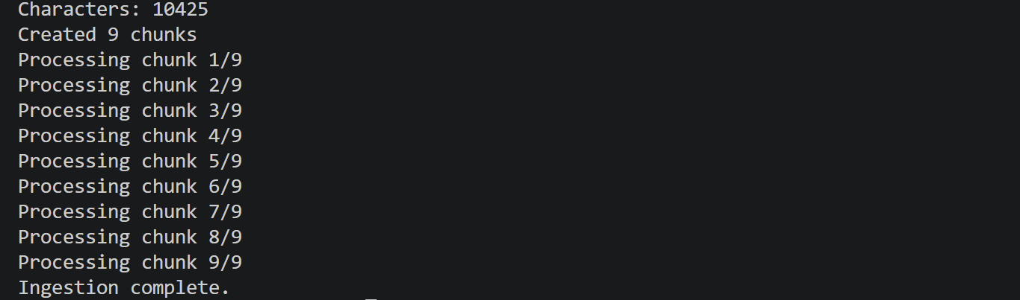
Screenshot 3.1 – Terminal – ingest.py
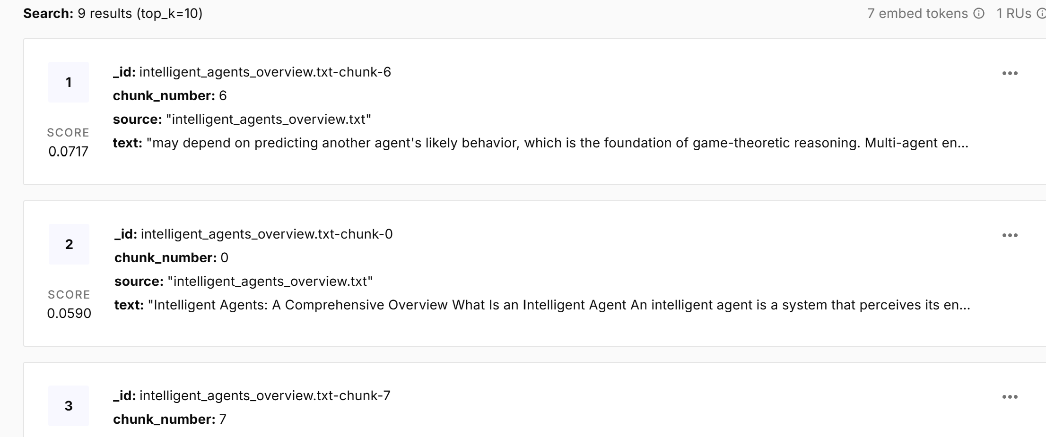
Screenshot 3.2 – Pinecone – a record from Python (DELIVERABLE)
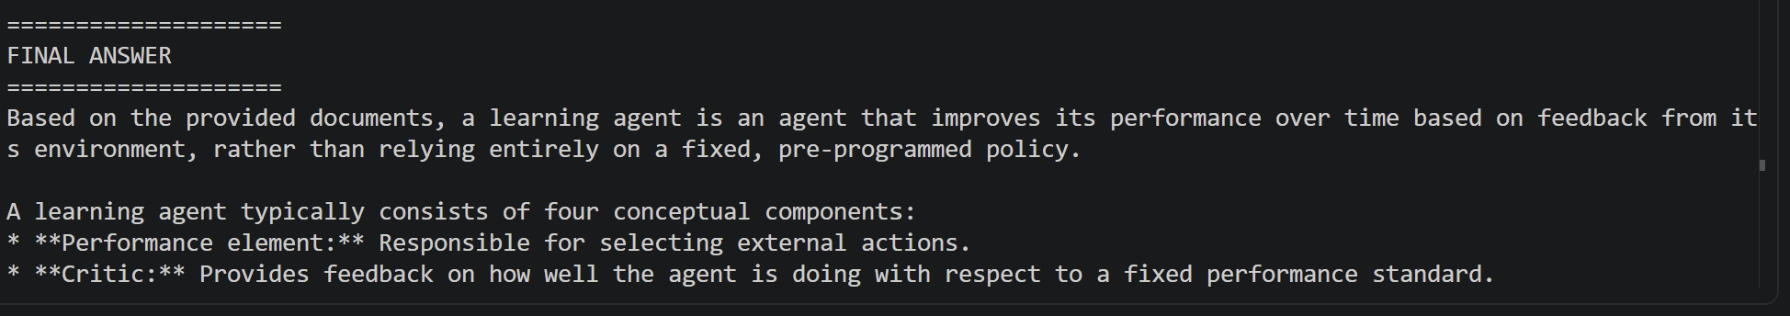
Screenshot 3.3 – Terminal – query.py answer (DELIVERABLE)
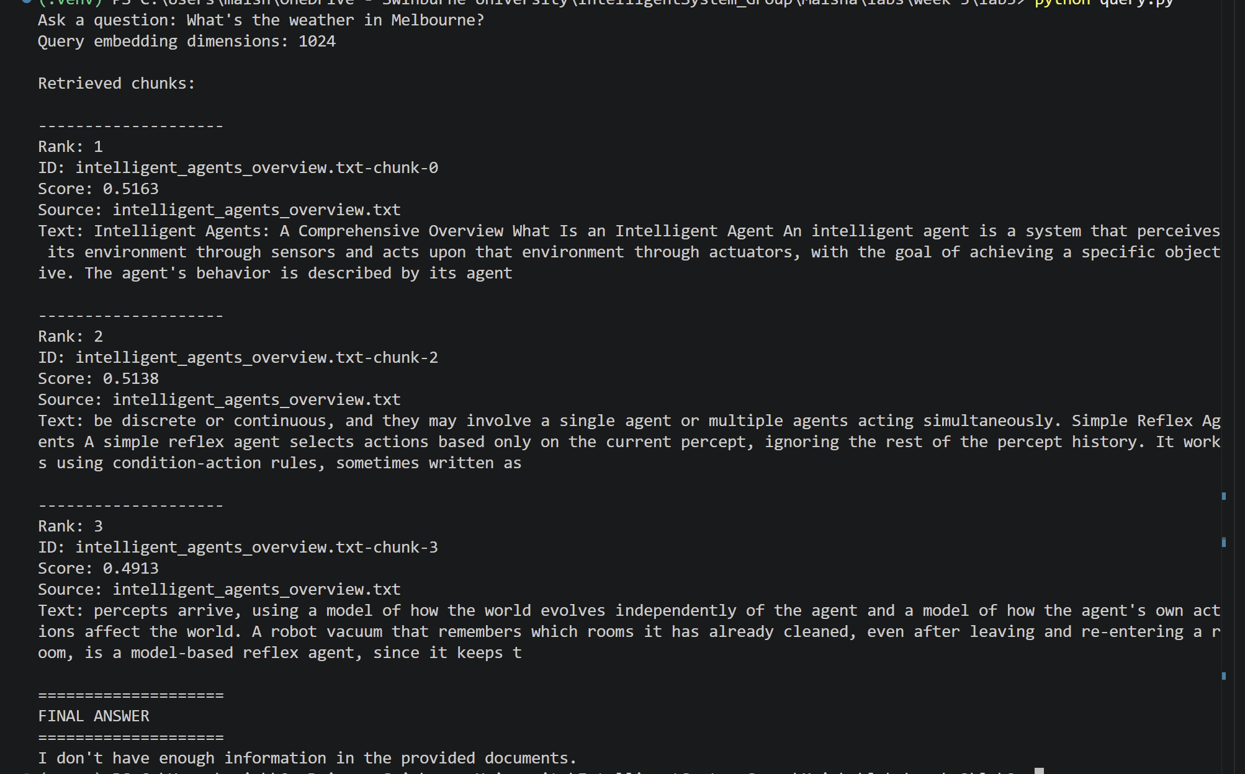
Screenshot 3.4 – Terminal – out-of-scope question
Deliverable – Part 1 (Make.com)
Modification: changed Limit (top-k) in the Pinecone 'Search with a query' module from 3 to 1 and to 5, and ran the same question again – at Limit 1 only chunk 0 came back (general agent definition) and the answer was "I don't have enough information in the provided documents."; at Limit 3 chunks 0, 5 and 4 came back and the answer was partial (2 of the 4 parts: performance element and critic); at Limit 5 two more on-topic chunks came back and the answer covered all 4 parts (performance element, critic, learning element, problem generator).
Deliverable – Part 2 (Python)
Out-of-scope question: it said "I don't have enough information in the provided documents." instead of making something up. Pinecone still returned 3 chunks (it always returns the closest ones), but the scores were much lower (about 0.49–0.52 vs 0.75–0.79 for the learning agent question) That's also why I always look at the retrieved chunks and their scores (Screenshot 3.11).
Modification – before/after (Experiment A, top-k): same question 'What is a learning agent?'. Result: top-k 1 → "not enough information", top-k 3 → partial answer (2 of 4 parts), top-k 5 → full answer (all 4 parts).
 | Chunks retrieved | Scores | Relevant | Context words | Answer words
top-k 1 | chunk 0 | 0.7870 | No – general agent definition only | 200 | 9
top-k 3 | chunks 0, 5, 4 | 0.7870, 0.7858, 0.7515 | 3 of 3 on topic (partial answer) | 600 | ~65
top-k 5 | chunks 0, 5, 4 + 2 more (incl. chunk 2) | same top 3; rank 5 = 0.7349 (chunk 2) | 5 of 5 on topic (full answer) | 800 | ~120
Modification – before/after (Experiment B, chunk size, top-k 3): relevant = the chunk contains the Learning Agents definition.
Experiment C – Make.com modules → Python
Operation | Make.com | Python
Load document | Google Drive → Download a File | Path(...).read_text()
Chunk text | Make AI Toolkit → Chunk text (200 / 20) | chunk_text(text, 200, 20)
Iterate chunks | Iterator | for i, chunk in enumerate(chunks):
Embed text | Google Gemini AI → Generate embeddings (1024) | embed_text(chunk) (embed_content)
Store vector | Pinecone → Create or Update a Record | index.upsert(namespace=..., vectors=[...])
Embed question | Google Gemini AI → Generate embeddings | embed_text(question)
Retrieve top-k | Pinecone → Search with a query (Limit 3) | index.query(vector=..., top_k=3, ...)
Aggregate context | Tools → Text aggregator (---) | "\n\n---\n\n".join(context_parts)
Generate answer | Google Gemini AI → Generate a response | gemini.interactions.create(...)
(question in / answer out) | Tools → Set variable / Get variable | input(...) / print(answer)
Checkpoint questions (Make.com sheet)
1. Which chunks did the vector DB retrieve for your question, and were they actually relevant?
For 'What is a learning agent?' it retrieved chunks 0, 5 and 4 of intelligent_agents_overview.txt (scores 0.7870, 0.7858 and 0.7515). Chunk 0 is the general definition of an intelligent agent, chunk 5 has the agent components (performance element, critic) and chunk 4 covers goal-based reasoning. All three were on topic, but on topic isn't the same as complete – with only 3 chunks Gemini could only give 2 of the 4 parts of a learning agent.
2. What happened when you asked a question with no matching content?
Pinecone still returned 3 chunks, because a top-k search always gives back the closest matches even when nothing really matches. The scores were much lower (about 0.49–0.52 vs 0.75–0.79 for the learning agent question), so the chunks were only weakly related. Gemini then answered "I don't have enough information in the provided documents." instead of making something up. So retrieval and the system instruction are two separate safeguards – the instruction is what actually keeps Gemini inside the context.
3. What changed after your modification?
I asked the same question at Limit 1, 3 and 5. At 1 only chunk 0 (the general agent definition) came back, so Gemini said it didn't have enough information. At 3 it gave a partial answer – only 2 of the 4 parts (performance element and critic). At 5 two more on-topic chunks came back and the answer had all 4 parts (adding learning element and problem generator). A higher top-k made the answer more complete without adding unrelated chunks, because the learning-agent info is spread over several chunks.
What I should be able to explain (Python sheet, section 11)
1. Why do we chunk a document instead of embedding the entire document as one vector?
One vector for the whole document would mix every topic into one 'average' meaning, so a question about one small part (like learning agents) wouldn't match it well. Chunks let the search find just the part that answers the question, and only that part gets sent to Gemini – shorter, cheaper and more focused.
2. What does the embedding model produce?
A list of numbers – here 1024 of them (a vector) – that stands for the meaning of the text. Texts that mean similar things get vectors that point in a similar direction.
3. Why must the document chunks and the question use the same embedding model and dimension?
Every model has its own 'map' of meaning, so vectors from two different models can't be compared – it's like comparing coordinates from two different maps. And Pinecone only accepts vectors of the index's size (1024), so the dimension has to match the index and both scripts.
4. What does Pinecone store for each record?
An id (e.g. intelligent_agents_overview.txt-chunk-0), the values (the 1024 numbers) and metadata (the chunk text, the source file name and the chunk_number), inside a namespace in my index.
5. What does cosine similarity help us find?
Chunks whose vector points the same way as the question's vector, i.e. chunks with a similar meaning even if they use different words. Close to 1 = very similar, close to 0 = unrelated.
6. What does top-k control?
How many of the most similar chunks come back and get pasted into the prompt. Small k = focused but might miss something; big k = more information but also more unrelated text and a longer prompt.
7. Why do we store the original chunk text as metadata if Pinecone already stores the vector?
You can't turn a vector back into text. Gemini needs the actual words as context, and I need them to check what was retrieved.
8. Where does retrieval end and generation begin?
Retrieval ends when Pinecone has returned the top-k chunks and I've joined them into one context string. Generation starts at gemini.interactions.create(...), when Gemini writes the answer from that context.
9. What is the purpose of the system instruction that says to answer only from context?
It keeps Gemini to my documents instead of its general knowledge, and gives it a fixed sentence to say when the context doesn't have the answer – so it's less likely to make things up. It's not a guarantee though, so I still check the retrieved chunks.
10. What part of the Python implementation corresponds to the Make Iterator?
The for i, chunk in enumerate(chunks): loop in ingest.py – it embeds and upserts one chunk at a time, just like the Iterator sends one chunk at a time to the Gemini and Pinecone modules.

